D604 OHN2 Task 1 Scenario: Image

Scenario
Image classification uses machine learning to identify and categorize visual data. The goal is to automatically distinguish objects or species in images, enabling experts to make faster and more accurate decisions.
In this scenario, you will refer to a labeled dataset of 4,750 RGB images representing 12 plant species, including both crop seedlings and common weeds. Effective species classification enables botanists and agricultural specialists to differentiate between crops and weeds at early growth stages, allowing for targeted treatment, increased crop yield, and improved environmental stewardship.
As the analyst, you will analyze the image data, prepare the images for modeling, and build a machine learning classifier that distinguishes among the seedling species.
Dataset Details
The given dataset contains 4,750 RGB images of species divided across 12 categories: "Small-flowered Cranesbill," "Fat Hen," "Shepherds Purse," "Common wheat", "Common Chickweed," "Charlock," "Cleavers," "Scentless Mayweed," "Sugar beet," "Maize," "Black-grass," and "Loose Silky-bent."
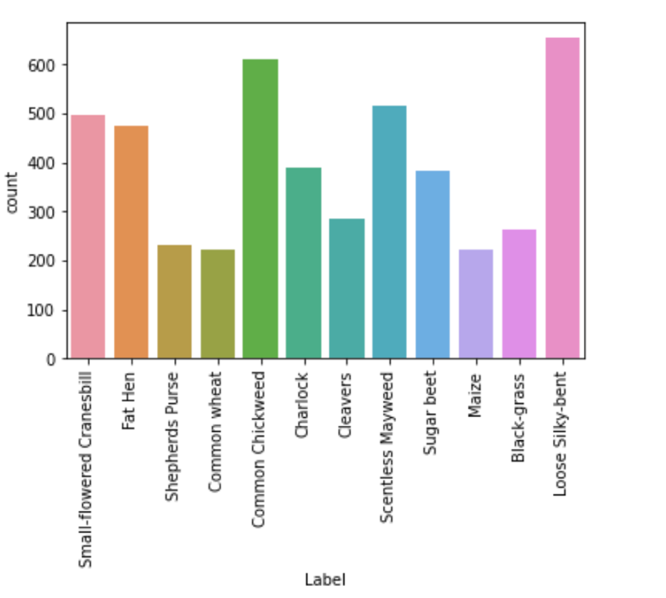
The dataset contains two files:
- images.npy—images in a numpy array format
- labels.csv—the labels in a .csv file
- Link to files

There are 4750 RGB images of shape 128 x 128 X 3 (i.e., each image has three channels).
Reading the Files
#Reading the files—assuming the files are in the same folder as the notebook/ide.
# Otherwise use the file path
images = images = np.load("images.npy")
labels = pd.read_csv("labels.csv")

print(images.shape)
>> (4750, 128, 128, 3)

print(labels.shape)
>> (4750, 1)
Example Images
